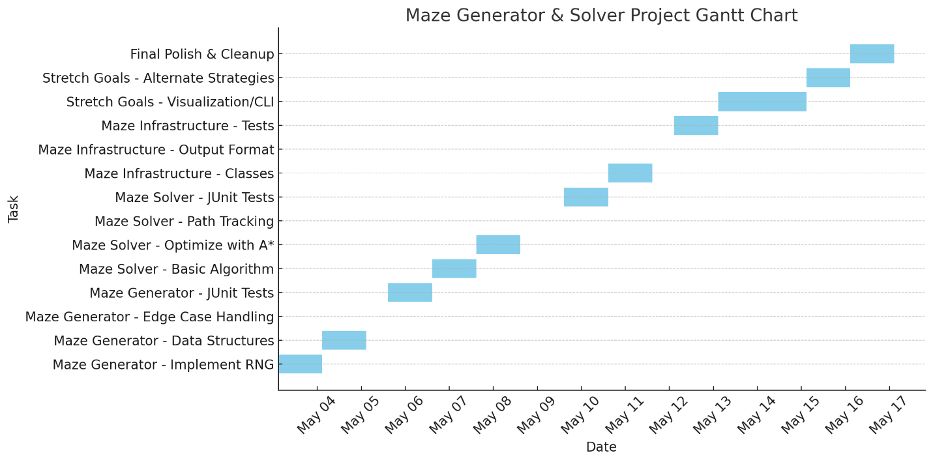
🧱 Maze Generator
- Implement MazeGenerator class
- Use seeded RNG to ensure reproducibility
- Use a maze generation algorithm (e.g., Recursive Backtracking, Prim's)
- Support variable maze dimensions (e.g., width, height)
- Guarantee at least one valid path from start to finish
- Output in a usable format (2D array, graph, etc.)
🧪 Maze Generator: JUnit Tests
- Test: Same seed generates identical mazes
- Test: Different seeds generate different mazes
- Test: All cells are reachable (no isolated sections)
- Test: Maze has a valid start and end point
- Test: Invalid inputs (e.g., 0x0 or negative size) throw exceptions

🧭 Maze Solver (MouseBot)
- Implement MazeSolver class
- Choose solving algorithm (e.g., BFS, DFS, A*, Right-hand rule)
- Ensure solver finds the shortest path
- Track cells visited, total time taken, and path length
- Output path as a list of coordinates or moves
🧪 Maze Solver: JUnit Tests
- Test: Solver finds a path on a valid maze
- Test: Solver finds the shortest path (A*)
- Test: Solver handles mazes with dead ends correctly
- Test: Solver completes within time limits
- Test: Edge cases (1x1 maze, narrow paths, loops)

🧩 Maze Structure / Utilities
- Define MazeCell class (walls, visited, etc.)
- Create Maze class to wrap grid and logic
- Add methods for cell access, entrance/exit setting
- Optional: Export maze to text or JSON
🧪 Maze Structure: JUnit Tests
- Test: Wall consistency between adjacent cells
- Test: Correct number of walls per cell after generation
- Test: Maze integrity after multiple generations

🧠 Advanced / Stretch Goals
- Parameterized tests for mazes of varying sizes
- Generate unsolvable mazes (for testing)
- Add multiple solving strategies (compare path lengths)
- Optional visualization or CLI output
- Optional: GUI for maze animation or builder

Phase 1: Core A* with Manhattan Distance
🎯 Goal: Build a working A* solver on a 2D maze with uniform cost and no directional logic
🔨 Features:
- Maze is a grid (e.g., MazeCell[][])
- Walls block movement
- A* searches using:
  - g(n) = steps from start
  - h(n) = Manhattan distance to goal
- No turn penalties or inertia
✅ Completion Criteria:
- MouseBot finds shortest path reliably
- Works for arbitrary maze sizes (e.g., 5x5, 10x10)
- JUnit tests verify:
  - Path exists
  - Path is shortest
  - Maze is solved within a time limit

⚙️ Phase 2: Direction-Aware Movement
🎯 Goal: Factor direction and turning cost into the algorithm
🔨 Features:
- MouseBot tracks current facing direction (N, E, S, W)
- Add turn penalties (e.g., 90° = +0.5)
- g(n) now includes step + turn costs
- A* considers same cell approached from different directions as different states
✅ Completion Criteria:
- Solver adapts to turning penalties
- JUnit tests verify that the path is:
  - Not necessarily the shortest in distance
  - Optimal in total cost (steps + turns)
- Directional logic is tested independently

🧠 Phase 3: Inertial Navigation (Potential Future Implementation)
🎯 Goal: Simulate real-world movement dynamics with inertia and speed
🔨 Features:
- Introduce acceleration/deceleration time
- Longer straight runs become cheaper per cell
- Sudden stops or sharp turns increase cost
- State includes speed and direction
✅ Completion Criteria:
- Solver selects fastest (least-time) path
- Tests simulate:
  - Slowing into turns
  - Gaining speed on straights
- JUnit covers edge cases: tight mazes vs. long corridors

